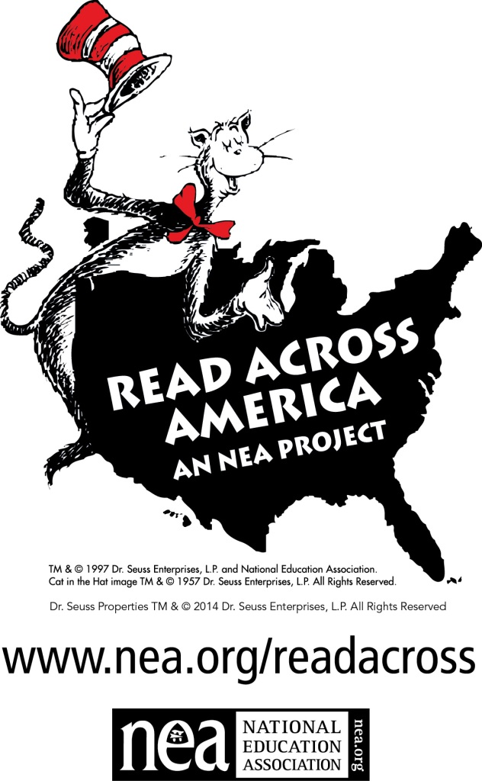
K. White Jr. High Celebrates “Read Across America” and Dr. Seuss’ Birthday
March 2-6, 2015
~Students –if you are a fan of Dr. Seuss and the books that he wrote then you know how to rhyme. Write a Poem about reading or books in Dr. Seuss’ style. Poem is due March 2nd!
~“Kid’s Crazy Hats” Students create your version of “the cat in the hat” hat for display only. Hat is due march 4th.
Teachers you are welcome to submit your entries too!

Monday –turn in your poem about reading/books in Dr. Seuss style.
Wednesday –turn in your crazy version of The Cat in the Hat hat ~to display in the library.
Friday – wear your favorite Dr. Seuss character t-shirt.
You're never too old, too wacky, too wild,
To pick up a book and read with a child.
You're never too busy, too cool, or too hot,
To pick up a book and share what you've got.
In schools and communities,
Let's gather around,
Let's pick up a book,
Let's pass it around.
There are kids all around you,
Kids who will need
Someone to hug,
Someone to read.
Come join us March 3rd
Your own special way
And make this America's
Read to Kids Day.
©Anita Merina
